**A**

**PROJECT REPORT**

**ON:**

**TO STUDY COMPARATIVE ANALYSIS ON THE BASIS OF COMPETITION DRIVE BETWEEN TOP OUTLETS IN SHRIRAMPUR REGION.**

**SUBMITTED TO:**



**SAVITRIBAI PHULE PUNE UNIVERSITY IN PARTIAL FULLFILLMENT FOR THE COURSE OF**

**MASTERS OF BUSINESS ADMINISTRATION (MBA)**

PROJECT REPORT SUBMITTED BY:

**KOKANE AKASH RAJENDRA**

UNDER THE GUIDANCE OF:

**PROF. DR. N.N DIGHE SIR**

**THROUGH:**

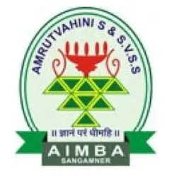

**AMRUTVAHINI INSTITUTE OF MANAGEMENT & BUSINESS ADMINISTRATION, SANGAMNER, AHMEDNAGAR (2021-2023)**

**DECLARATION**

I, the undersigned Mr. Kokane Akash Rajendra, hereby declare that this summer internship project work on “***Study of comparative analysis on the basis of competition drive between top outlets in Shrirampur region”*** is fulfilment of Masters of Business Administration degree course of Savitribai Phule University is my own work & submitted by me under the guidance of Dr. N.N. Dighe. I also declare that the present work has not been submitted by us to any other university or the fulfilment of the any degree or diploma. I have prepared this report independently & I have gathered all the relevant information personally.

I have prepared this project for MBA curriculum 2022-2023

**Place:** Sangamner Mr. Kokane Akash Rajendra

**Date: / /**

**ACKNOWLEDGEMENT**

The success and final outcome of this project required a lot of guidance and assistance from many people and I am extremely fortunate to have got this all along the completion of my project work. Whatever I have done is only due to such guidance and assistance and I would not forget to thank them.

I wish to avail this opportunity to express my deep sense of gratitude and humble indebtedness towards my Honourable Research Guide **Dr.N.N Dighe** Associate Professor & Exam Co-ordinator, Amrutvahini Institute of Business Administration and Management, Sangamner for his valuable guidance, immense support, untiring interest, valuable comments, co-operation and consistent encouragement throughout the course of my post-graduation study and also gave me this unique experience of planning, conducting, and presenting the research.

I take this opportunity to thank **Ms. Priti Ma’am** (HR-ITC ltd), Pune for allowing me to complete my internship in this renowned Multinational Company. I would also Thank **Mr. Mithilesh Lokashi** for being my guide & a wonderful Mentor in ITC ltd. His guidance and constant support played a vital role in completion of this research project.

My words fail to express my deep sense of gratitude towards my beloved Parents for their immense support, guidance, love and affection which inspired me during the period of my study. Some special words of gratitude go to my senior **Miss. Anshula Deshmukh** and my friends **Aditya, Sayli, Rutuja**, **Prajwal & Nisha** who have always been a major source of support when things would get a bit discouraging. Thanks guys, for being there for me.

Once again, I like to acknowledge all those whom I might have left unknowingly.

**Place:** Sangamner

**Date:  / /**

**INDEX**

|  |  |  |
| --- | --- | --- |
| **SR.NO** | **TITLE** | **PAGE NO** |
| 1 | Executive Summery | 1 |
| 2 | Introduction | 2 |
| 3 | Industry Profile | 3&4 |
| 4 | Company Profile | 5&6 |
| 5 | Organisational structure | 7&8 |
| 6 | Product Profile | 9-14 |
| 7 | Theoretical Background | 15 |
| 8 | Research Methodology: | 16-19 |
| 9 | 1. Rational of the study 2. Objectives of the study 3. Research Design 4. Sources of data collection 5. Sample Design 6. Scope of the study 7. Need of the study 8. Significance of the study 9. Limitations of the study 10. Statistical Tools | 16  16  16  17  17  18  18  18  19  19 |
| 10 | Data Analysis & Interpretation | 20-32 |
| 11 | Comparative Analysis Outcomes | 33 |
| 11 | Findings, conclusion & Suggestions of the study: | 34&35 |
|  | 1. Findings 2. Conclusion 3. Suggestions | 34  35  35 |
| 12 | Bibliography | 36 |
| 13 | Annexure | 37&38 |

**CHAPTER:01**

**EXECUTIVE SUMMERY:**

**Topic:** “*Study of comparative analysis on the basis of competition drive between top outlets in Shrirampur region”.*

**Purpose of the research study:**

1. To know the different strategies of competitors regarding pay-outs given to top outlets in the region of Shrirampur.
2. To know what are the parameters on which the pay-outs is being claim by top outlets.
3. To know the top outlets perception towards ITC on the basis of Pay outing, Target communication, Auditor Info & Visual Display.

This project is carried out with intention of knowing how are competitors competing in the market with regarding top outlets. What are the different strategies carried out by them, on what basis the pay-outs are been given to these outlets, are there any special schemes offered to them by different companies? Through this researcher can be able to interpret the data & able to derive best possible outcome to compete in the market. Thus, this project carries it’s important to make the difference in marketing strategies.

I have conducted interviews of **19** top outlets owners in Shrirampur region. Through those interviews I have landed upon below mentioning findings.

1. Companies like Britannia, Nestle, HUL do give pay-outs when targets are achieved but Parle doesn’t give pay-outs but offers better schemes/margin than ordinary outlets to these top outlets.
2. Target communication is done meanly with Mobile App & SMS, target communication with invoice is not carried out by most pf the companies except Cadbury.
3. Most of the pay-outs are given on the basis of shelves then that of End caps, Racks etc.

* **Through the study there are some suggestions which I would like to share with ITC ltd:**

1. Target communication with top outlets like Groceries & Bakeries should be improved, these outlets are not aware about their targets.
2. ITC should focus more on product offerings & visual displays which will help in brand awareness among the customers coming into these outlets.
3. Proper guidance should be given to these outlets about Unnati app so that awareness about different information about products can be known by them.

**CHAPTER:02**

**INTRODUCTION:**

This project revolves around top outlets and the competition driven by companies in them. Since these outlets are top performer, every company wants that their products should be available in those outlets. Which will result is increase in sales. So, to convenes these outlets lots of different profitable programs are carried out like Pay-outs on target achievement, better schemes are provided which are far more than ordinary outlets. So, how can ITC play its role in best possible way so that pay outings & schemes provided will be best then the competitors.

**What are Top Outlets?**

When any outlet which is taking the products from a company is also register to that particular company simultaneously. Thus, these retail stores are under the eye of the company and their performance is also recorded. Company evaluates the retail stores on the basis of sales generated by them. The retail with maximum sales & turnover is selected in the top outlet program. These outlets can be ISS (Independent self-service) stores, Grocery, Bakery & Chemist.

**Top Outlet Programs:**

The top outlet program is carried out by different companies in their own way where they offer different pay-outs, Schemes, Visual Displays & Targets. Since these outlets order are in bulk quantity companies offers also provides some product offering like Baskets, racks, hangers, Fridge etc. These offerings work as a motivation for these outlet owners to perform well.

**Functioning of Top Outlet Programs:**

Once the retail outlet is selected on the basis of performance, they are enrolled to top outlet program these outlets are given pay-outs on completion of target. These targets are communicated through different platforms such as Mobile Apps, SMS, WhatsApp & Invoice. Meanly targets are given on monthly basis. After achieving the target, the decided amount is directly transferred into the bank account of that retailer.

**Purpose of the study:**

Since the top outlet programs are booming its popularity, every company is looking forward to increase their sales and earn good profits. Since, the companies like Britannia, Nestle, HUL, Parle etc have been capturing the market through these programs where ITC is also playing its role. But to be competitive in the competition company should always be one step ahead of the competitors. Thus, researcher is focusing on comparative analysis on the basis on competition drive between top outlets in Shrirampur region.

Through this study researcher can tap the flaws, and also be able to understand what other companies are providing differently & lastly what is the perception of top outlets about schemes provided by the companies like Pay-outs, Target Communication & Visual Display.

**CHAPTER:03**

**INDUSTRY PROFILE:**

Fast-moving consumer goods (FMCG) sector is India’s fourth-largest sector and has been expanding at a healthy rate over the years as a result of rising disposable income, a rising youth population, and rising brand awareness among consumers. With household and personal care accounting for 50% of FMCG sales in India, the industry is an important contributor to India’s GDP.

India is a country that no FMCG player can afford to ignore due to its middle-class population which is larger than the total population of USA. The Indian FMCG market continues to rise as more people start to move up the economic ladder and the benefits of economic progress become accessible to the general public. More crucially, with a median age of just 27, India's population is becoming more consumerist due to rising ambitions. This has been further aided by government initiatives to increase financial inclusion and establish social safety nets.

Growing awareness, easier access and changing lifestyles have been the key growth drivers for the sector. The urban segment (accounts for a revenue share of around 55%) is the largest contributor to the overall revenue generated by the FMCG sector in India. However, in the last few years, the FMCG market has grown at a faster pace in rural India compared to urban India. Semi-urban and rural segments are growing at a rapid pace and FMCG products account for 50% of the total rural spending

The retail market in India is estimated to reach US$ 1.1 trillion by 2020 from US$ 840 billion in 2017, with modern trade expected to grow at 20-25% per annum, which is likely to boost revenue of FMCG companies. The FMCG market in India is expected to increase at a CAGR of 14.9% to reach US$ 220 billion by 2025, from US$ 110 billion in 2020. The Indian FMCG industry grew by 16% in CY21 a 9- year high, despite nationwide lockdowns, supported by consumption-led growth and value expansion

from higher product prices, particularly for staples. The Indian processed food market is projected to expand to US$ 470 billion by 2025, up from US$ 263 billion in 2019-20.

FMCG giants such as Johnson & Johnson, Himalaya, Hindustan Unilever, ITC, Lakmé and other companies (that have dominated the Indian market for decades) are now competing with D2C-focused start-ups such as Mamaearth, The Moms Co., Bey Bee, Azah, Nua and Pee Safe. Market giants such as Revlon and Lotus took ~20 years to reach the Rs. 100 crore (US$ 13.4 million) revenue mark, while new-age D2C brands such as Mamaearth and Sugar took four and eight years, respectively, to achieve that milestone.

Advertising volumes on television recorded healthy growth in the July-September quarter, registering 461 million seconds of advertising, which is the highest in 2021. FMCG continued to maintain its leadership position with 29% growth in ad volumes against the same period in 2019. Even the e-commerce sector showed a healthy 26% jump over 2020.

Rural consumption has increased, led by a combination of increasing income and higher aspiration levels. There is an increased demand for branded products in rural India. On the other hand, with the share of unorganised market in the FMCG sector falling, the organised sector growth is expected to rise with increased level of brand consciousness, augmented by the growth in modern retail. Another major factor propelling the demand for food services in India is the growing youth population, primarily in urban regions. India has a large base of young consumers who form majority of the workforce, and due to time constraints, barely get time for cooking.

Online portals are expected to play a key role for companies trying to enter the hinterlands. Internet has contributed in a big way, facilitating a cheaper and more convenient mode to increase a company’s reach. The number of internet users in India is likely to reach 1 billion by 2025. It is estimated that 40% of all FMCG consumption in India will be made online by 2020. E-commerce share of total FMCG sales is expected to increase by 11% by 2030. It is estimated that India will gain US$ 15 billion a year by implementing GST. GST and demonetisation are expected to drive demand, both in the rural and urban areas, and economic growth in a structured manner in the long term and improved performance of companies within the sector.

*****

**CHAPTER:04**

**COMPANY PROFILE:**

ITC is one of India's foremost private sector companies and a diversified conglomerate with businesses spanning Fast Moving Consumer Goods, Hotels, Paperboards and Packaging, Agri Business and Information Technology. The Company is acknowledged as one of India's most valuable business corporations with a Gross sales value of ₹ 90,104 crores and Net Profit of ₹ 15,058 crores (as on 31.03.2022). ITC was ranked as India's most admired company, according to a survey conducted by Fortune India, in association with Hay Group.

**Multiple Drivers of Growth:**

ITC is the country's leading FMCG marketer, the clear market leader in the Indian Paperboard and Packaging industry, a globally acknowledged pioneer in farmer empowerment through its wide-reaching Agri Business, a pre-eminent hotel chain in India that is a trailblazer in 'Responsible Luxury'. ITC's wholly-owned subsidiary, ITC Infotech, is a specialized global digital solutions provider.

Over the last decade, ITC's new Consumer Goods Businesses have established a vibrant portfolio of ***25 world- class Indian brands*** that create and retain value in India. ITC's world class FMCG brands including Aashirvaad, Sunfeast, Yippee! Bingo! B Natural, ITC Master Chef, Fabelle, Sunbean, Fiama, Engage, Vivel, Savlon, Classmate, Paperkraft, Mangaldeep, Aim and others have garnered encouraging consumer franchise within a short span of time. While several of these brands are market leaders in their segments, others are making appreciable progress.

**Leveraging Institutional Strengths:**

The competitiveness of ITC's diverse businesses rest on the strong foundations of institutional strengths derived from its ***deep consumer insights, cutting-edge Research & Development, differentiated product development capacity, brand-building capability, world-class manufacturing infrastructure, extensive rural linkages, efficient trade marketing and distribution network and dedicated human resources.*** ITC's ability to leverage internal synergies residing across its diverse businesses lends a unique source of competitive advantage to its products and services.

**'Nation First: Sab Saath Badhein':**

ITC's ***'Nation First: Sab Saath Badhein'*** philosophy underlines its core belief in building a globally competitive and profitable Indian enterprise that makes an exemplary contribution to creating larger societal value. As a company deeply rooted in Indian soil, ITC is inspired by the opportunity to serve larger national priorities. A global exemplar in Sustainability***, ITC is the only enterprise in the world of comparable dimensions to be carbon-positive, water-positive and solid waste recycling positive for over a decade now. ITC has created over 6 million sustainable livelihoods.*** Nearly 42% of the total energy consumed in ITC is from renewable sources. ITC's premium luxury hotels have the unique distinction of being LEED Platinum certified.

ITC's Well-being Out of Waste programme (WOW) that comprehensively addresses the problem of solid waste management, of which plastic waste is a significant component, provides an end-to-end sustainable and scalable solution that has reached out to over 1.8 crores citizens in the country.

Together with farmers and local communities, ITC has implemented largescale interventions in climate-smart and sustainable agriculture that make a meaningful contribution to the Hon'ble Prime Minister's vision of doubling farmer incomes. Towards this, ITC has launched an integrated programme titled ***'Baareh Mahine Hariyali'*** (maximising farm utilisation over 12 months of the year) to give a new dimension to the complex task of multiplying farmer incomes. ITC is collaborating with NITI Aayog to progressively build capacity of 2 million farmers in 27 Aspirational Districts to help enhance rural incomes.

ITC is investing in India's future by building ***world-class consumer goods factories and iconic hospitality assets*** that will contribute to the country's competitive capacity. These investment projects underpin the Company's support to the Government's "Make in India" vision.

**\*\*\*\*\***

**CHAPTER:05**

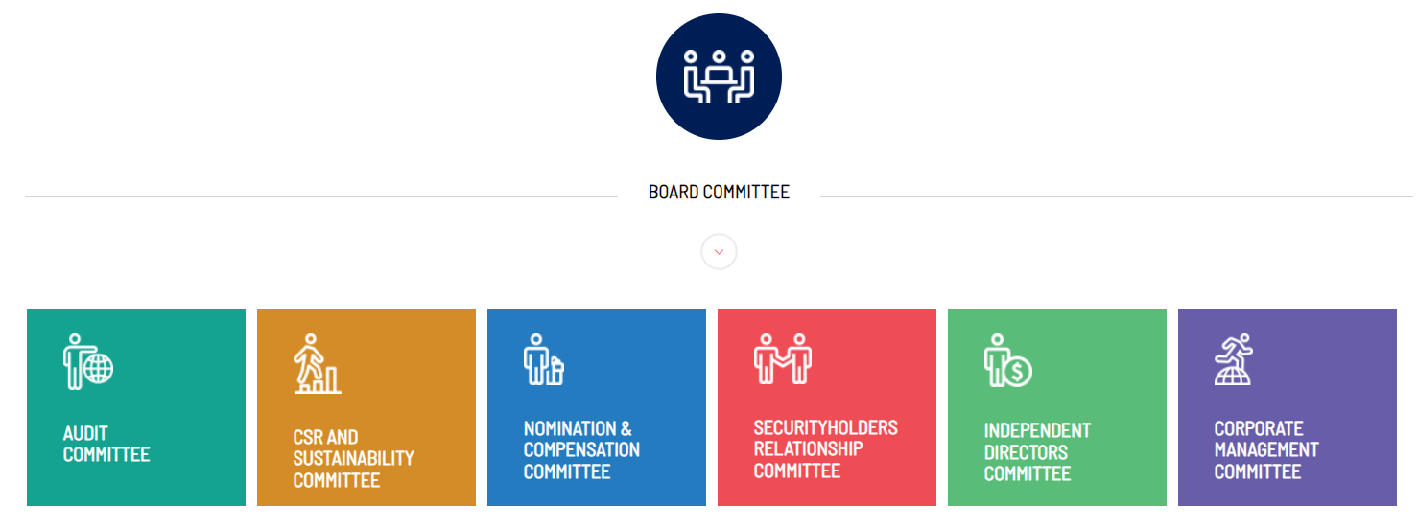**ORAGANISATIONAL STRUCTURE:**

**BOARD COMMITTEE:**

* **AUDIT COMMITTEE:**

|  |  |  |
| --- | --- | --- |
| **SR.NO** | **COMMITTEE MEMBERS** | **DESIGNATION** |
|  | Mr. A. Duggal | Chairman |
|  | Mr. S. Banerjee | Member |
|  | Mr. Hemant Bhargava | Member |
|  | Mr. Supratim Dutta | Invitee |
|  | Mr. M. Ganesan | Invitee |
|  | Mr. R. K. Singhi | Secretory to the committee |

* **CSR & SUSTAINABILITY COMMITTEE:**

|  |  |  |
| --- | --- | --- |
| **SR.NO** | **COMMITTEE MEMBERS** | **DESIGNATION** |
|  | Mr. S. Puri | Chairman |
|  | Mr. N. Doda | Member |
|  | Mr. Mukesh Gupta | Member |
|  | Mr. S. Panray | Member |
|  | Ms. Nirupama Rao | Member |
|  | Mr. A. K. Seth | Member |
|  | Ms. M. Shankar | Member |
|  | Mr. David Simpson | Member |
|  | Mr. R. K. Singhi | Secretary to the Committee |

* **SECRETARY TO THE COMMITTEE:**

|  |  |  |
| --- | --- | --- |
| **SR.NO** | **COMMITTEE MEMBERS** | **DESIGNATION** |
| 1. | Mr. S. Banerjee | Chairman |
| 2. | Mr. A. Nayak | Member |
| 3. | Mr. S. Puri | Member |
| 4. | Ms. M. Shankar | Member |
| 5. | Mr. R. K. Singhi | Secretary to the Committee |

* **SECURITYHOLDERS RELATIONSHIP COMMITTEE:**

|  |  |  |
| --- | --- | --- |
| **SR.NO** | **COMMITTEE MEMBERS** | **DESIGNATION** |
| 1. | Mr. A. Nayak | Chairman |
| 2. | Mr. N. Doda | Member |
| 3. | Mr. Supratim Dutta | Member |
| 4. | Mr. B. Sumant | Member |
| 5. | Mr. R. K. Singhi | Secretary to the Committee |

* **INDEPENDENT DIRECTORS COMMITTEE**:

|  |  |  |
| --- | --- | --- |
| **SR.NO** | **COMMITTEE MEMBERS** | **DESIGNATION** |
|  | Mr. S. Banerjee | Member |
|  | Mr. Hemant Bhargava | Member |
|  | Mr. A. Duggal | Member |
|  | Mr. S. Mukherjee | Member |
|  | Mr. A. Nayak | Member |
|  | Ms. N. Rao | Member |
|  | Mr. A.K. Seth | Member |
|  | Ms. M. Shankar | Member |

*****

**CHAPTER:06**

**PRODUCT PROFILE**

**BISCUITS:**

* 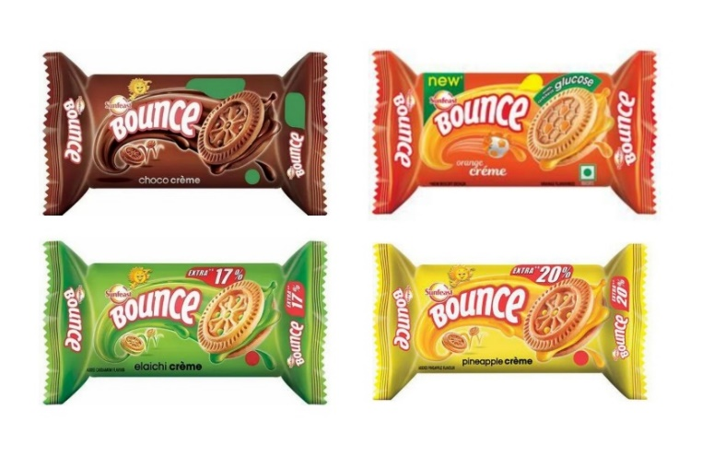**VALUE CREAM:**

**Flavours:**

1. Bounce Chocolate Cream
2. Bounce Orange Cream
3. Bounce Elaichi Cream
4. Bounce Pineapple Cream

* 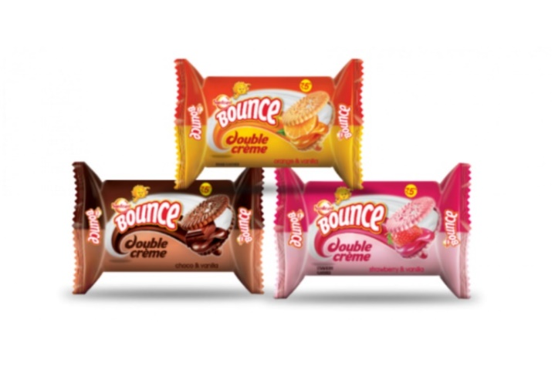**DOUBLE CREAM:**

**Flavours:**

1. Bounce Orange-vanilla Cream
2. Bounce Chocolate-vanilla Cream
3. Bounce Strawberry-vanilla Cream

* **MARIE:**
* **CORE COKIES:**

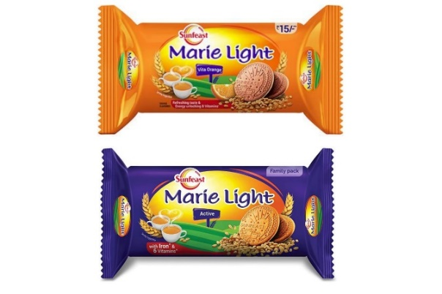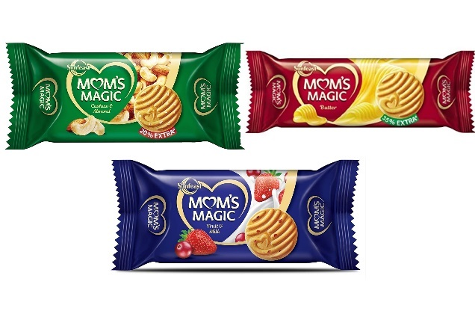

**Flavours:**

1. Marie Light Active
2. Marie Light Vita Ornge

**Flavours:**

1. Mom’s Magic Cashew
2. Mom’s Magic Butter
3. Mom’s Magic Fruit & Milk

* **PREMIUM DARK FANTASY:**

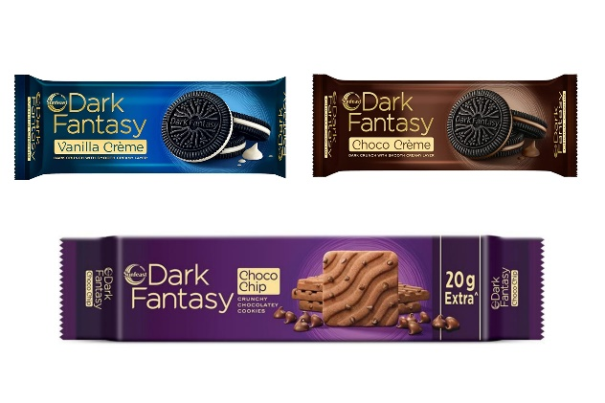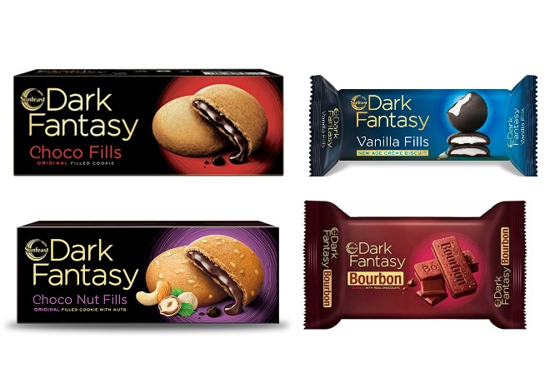

**Flavours:**

1. DF Choco Fills
2. DF Choco Nut Fills
3. DF Vanilla Fills
4. DF Bourbon

**Flavours:**

1. DF Vanilla Crème
2. DF Choco Crème
3. DF Choco Chip

* **all-rounder, Nice, Farmlite:**

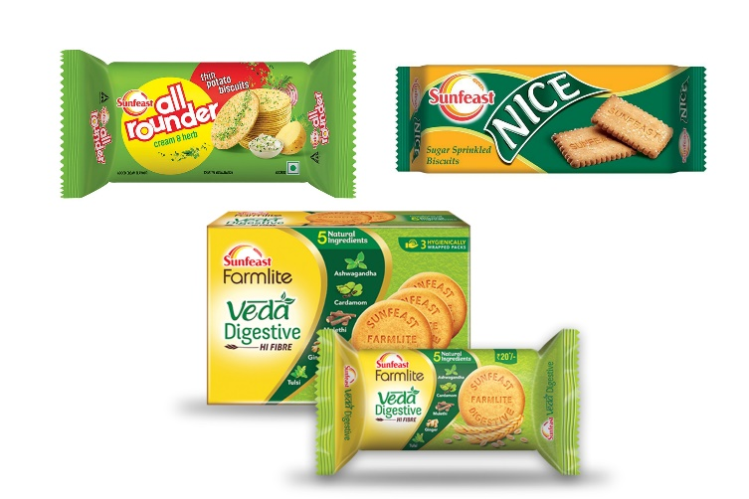

**Flavour:**

1. All Rounder Cream & Herb
2. Nice Sugar Sprinkled Biscuits
3. Veda Digestive

**SNACKS:**

* 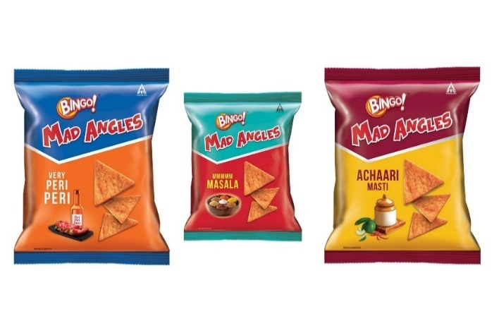**MAD ANGLES:**

**Flavours:**

1. MA Peri-Peri
2. MA mmmm Masala
3. MA Achaari Masti

* 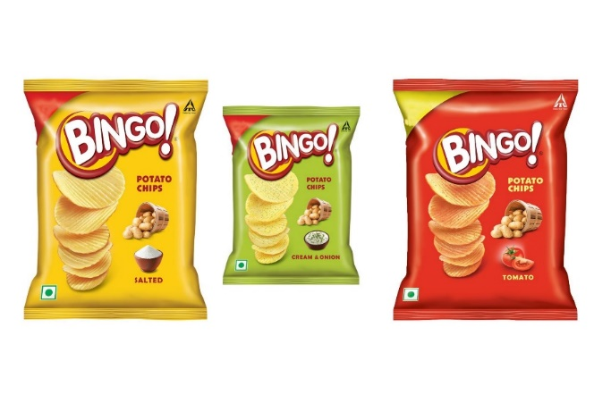**POTATO CHIPS:**

**Flavours:**

1. PC Salted
2. PC Cream & Onion
3. PC Tomato

* 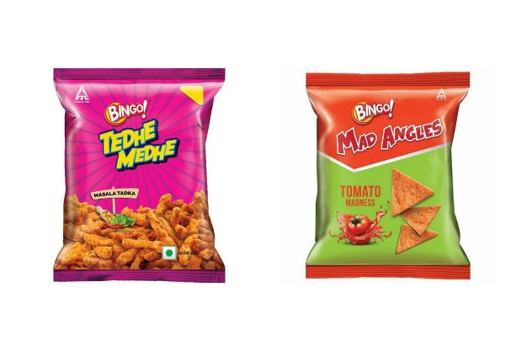**BIONG!**

**Flavours:**

1. Tedhe Medhe Masala Tadka
2. Mad Angles Tomato Madness

* **NO RULZ:**

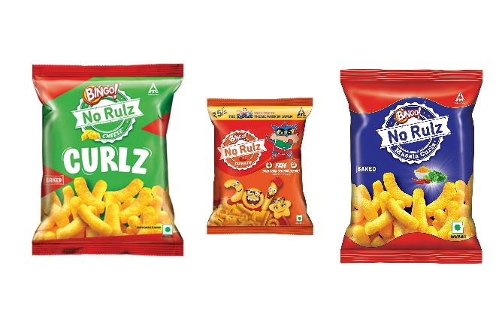

**Flavours:**

1. Cheese Curlz
2. Tomato Curlz
3. Masala Curl

* 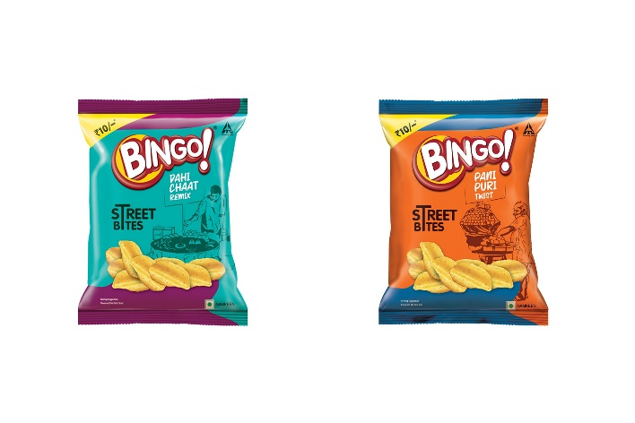**STREET BITES:**

**Flavours:**

1. SB Dahi Chaat Remix
2. SB Pani Puri Twist

**NOODLES & PASTAS:**

* **YIPPEE!**

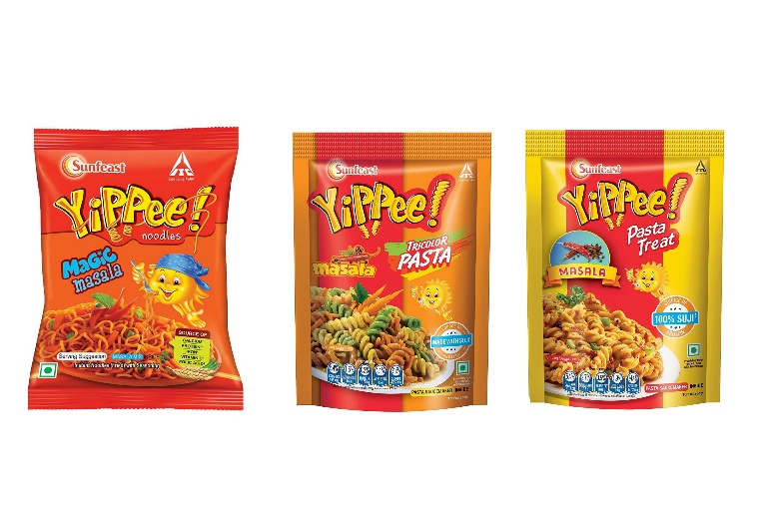

**Flavours:**

1. Yippee! Magic Masala
2. Yippee! Tricolor Pasta
3. Yippee! Pasta Treat

**ATA & READY TO EAT:**

* 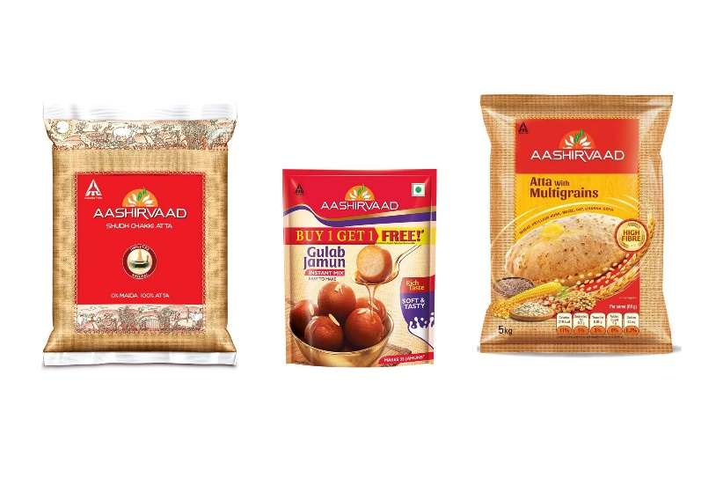**ASHIRVAAD:**

**Types:**

1. Whole Wheat Atta
2. Multi Grain Atta
3. Gulab Jamun

**CONFECTIONERIES:**

* **CANDYMAN TOFFEE:**

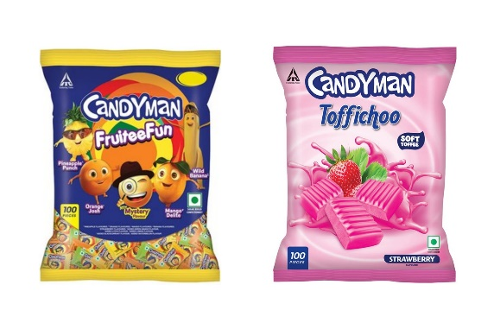

**Flavours:**

1. CM Fruitee Fun
2. CM Toffichoo
3. CM Fruitee Fun 3 in 1

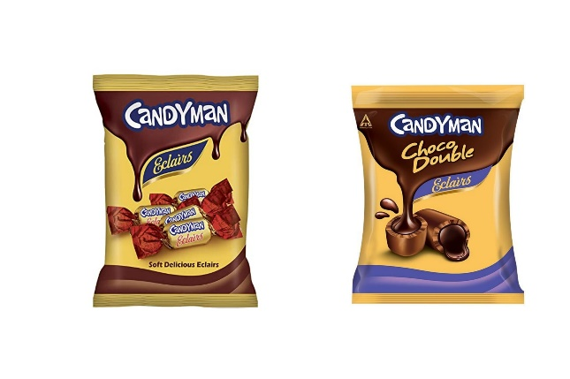

**Flavours:**

1. CM Soft Delicious Eclairs
2. CM Choco Double Eclairs

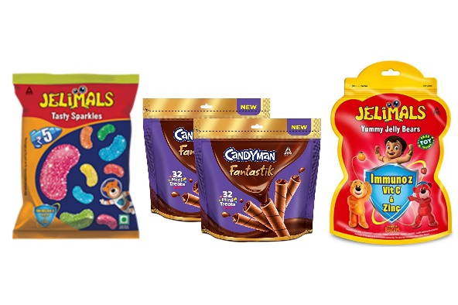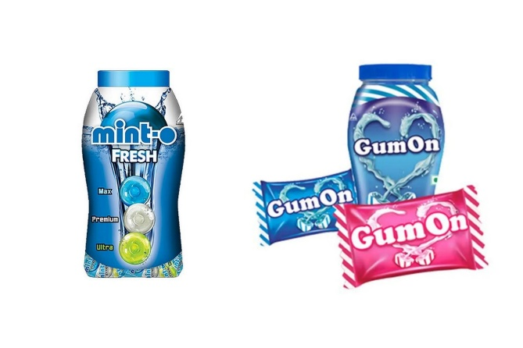

..

**Types:**

1. Minto Fresh
2. Gum On Chewing Gum

**Types:**

1. CM Fantastik
2. Jelimals Tasty Sparkles
3. Jelimals Yummy Jelly Bears

*****

**CHAPTER:07**

**THEORITICAL BACKGROUND:**

**What is a competitive analysis?**

A competitive analysis is a strategy that involves researching major competitors to gain insight into their products, sales, and marketing tactics. Implementing stronger business strategies, warding off competitors, and capturing market share are just a few benefits of conducting a competitive market analysis.

A competitive analysis can help you learn the ins and outs of how your competition works, and identify potential opportunities where you can out-perform them.

It also enables you to stay atop of industry trends and ensure your product is consistently meeting and exceeding industry standards.

**Let's dive into a few more benefits of conducting competitive analyses:**

* Helps you identify your product's unique [value proposition](https://blog.hubspot.com/marketing/write-value-proposition?_ga=2.98982557.2070896706.1604678379-1329357030.1604678379) and what makes your product different from the competitors', which can inform future marketing efforts.
* Enables you to identify what your competitor is doing right. This information is critical for staying relevant and ensuring both your product and your marketing campaigns are outperforming industry standards.
* Tells you where your competitors are falling short which helps you identify areas of opportunities in the marketplace, and test out new, unique marketing strategies they haven't taken advantage of.
* Learn through customer reviews what's missing in a competitor's product, and consider how you might add features to your own product to meet those needs.
* Provides you with a benchmark against which you can measure your growth.

**What is Competition Drive?**

“Competition is a key driver of innovation. In open and competitive markets, firms are driven to adopt more efficient production processes, and to offer new and improved products and services to customers,”

*****

**CHAPTER:08**

**RESEARCH METHODOLOGY:**

1. **RATIONAL OF THE STUDY:**

The main objective behind the study is to know what competition drive is focused by different companies in different types of top outlets like ISS, grocery & Bakery. Through the comparative study researcher will be able to find best possible way to provide better services to those outlets then other companies.

1. **OBJECTIVES OF THE STUDY:**
2. To study impact of display advertising strategies of different companies in top outlets.
3. To study impact of pay-outs on sales of product in top outlets.
4. To study product offerings of different companies in top outlets.
5. To study retailer perception towards ITC in top outlets.
6. **RESEARCH DESIGN:**
7. **Descriptive research:**

***Def:*** *Descriptive research is defined as a “research method that describes the characteristics of the population or phenomenon studied. This descriptive methodology focuses more on the “what” of the research subject than the “why” of the research subject. "*

* Thus, going through research, researcher wanted to understand what competition drive was focused by different companies in Top Outlets in Shrirampur region. The reason behind the research was to know the what other companies were doing so that ITC would work on it and improve. This was done through keeping descriptive research design in mind.

1. **Exploratory research:**

***Def:***  *In this type of research, researchers try to uncover the hidden and unknown facts and phenomena. This kind of research is helpful in exploring the information for problems which have not been defined precisely. It is also called as* *formulative research. It tries to answer the questions with appropriate reasons.*

* Thus, going through research & after having the conversation with owners of these top outlets research came to know about lots on unknown facts & problems on the basis of pay-outs & target communications through use of exploratory research design.

1. **SOURCES OF DATA COLLECTION:**
2. **Primary:**

*Primary sources provide raw information and first-hand evidence. Examples include interview transcripts, statistical data, and works of art. A primary source gives you direct access to the subject of your research.*

* Thus, researcher have collected the data by conducting interviews of owners of top outlets & through Questioners which are the primary source of data collection.

1. **Secondary:**

*Secondary data is the data that has already been collected through primary sources and made readily available for researchers to use for their own research. It is a type of data that has already been collected in the past*

* Thus, researcher have collected the secondary data through Portable Document Format that is PDFs of different schemes related to top out-lets.

1. **SAMPLE DESIGNE:**
2. **Sample Size:**

For the statistical data researcher did survey of **19** people through circulating Questioners.

1. **Sample Population:**

For the Survey of research, researcher focused on owners of top outlets or in charged person for responses.

1. **Sample Area:**

For the survey of research, researcher focused on the top outlets within the Shrirampur region

1. **Sample Technique:**

Researcher has taken Stratified Random Sampling from Probability Sampling technique to study the samples from groups under top outlets like ISS, Bakery & grocery where researcher can get adequate response related to the research.

1. **SCOPE OF THE STUDY:**
2. Through this research, researcher will get to know on what basis the pay-outs are paid to top outlets by companies.
3. To understand how targets are communicated by the companies to outlet owners.
4. To understand the perception of top outlets regarding ITCs pay outing, target communication, auditor info & visual display.
5. **NEED OF THE STUDY:**
6. To understand how the marketing strategies are carried out for selling the products in different categories of Top outlets like ISS, Grocery, Bakery & Chemist.
7. To understand how the pay-outs are given to the Top outlets by companies & what are the criteria for the pay-outs.
8. To know what is the perception of top outlets about different schemes provided by TIC & how should company improve it in best possible way.
9. **SIGNIFICANCE OF THE STUDY:**
10. Through this study researcher can understand what improvement can be done in different areas like visual display, product offering, way of pay-outing etc.
11. Through this researcher can understand how other companies are providing pay-outs on the different
12. **LIMITATIONS:**
13. No historical information was available for reference.
14. Secrecy of information made it difficult to understand actual stats.
15. Time duration of the study.
16. Due to lack of involvement of respondent due to festive season the data which researcher was able to fetched was not 100% accurate.
17. **STATISTICAL TOOLS:**

*The information collected through conducting survey is analysed by using following statistical tools****:***

1. Histogram
2. Pie Chart

**\*\*\*\*\***

**CHAPTER:09**

**DATA ANALYSIS & INTERPRITATION:**

1. **TOOLS OF DATA COLLECTION:**

|  |  |  |
| --- | --- | --- |
| **Sr.no** | **Sources** | **Primary Data** |
| 1 | Survey Instrument | Questionnaires |
| 2 | Source of Data | Google Forms |
| 3 | Sample Size | 19 |

**Que.1: Which type of outlet is this?**

**Table No: 1**

|  |  |  |  |
| --- | --- | --- | --- |
| **Sr.no** | **Responses** | **No. of Respondents** | **Percentages** |
| 1 | ISS | 10 | 52.6% |
| 2 | Grocery | 4 | 21.1% |
| 3 | Bakery | 4 | 21.1% |
| 4 | Chemist | 1 | 5.3% |

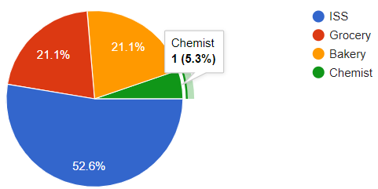

**Analysis:**

1. As per the Table No.1 respondents were asked that which type of outlet was that? where 52% were ISS stores, 21.1% Grocery & Bakery respectively & 1% Chemist.

**Interpretation:**

* From above Pie Chart researcher can interpret that, maximum outlets are ISS within the program of top outlets with 52.6% courtesy, the sales in those outlets are more in number as compared to other outlets

**Que.2: Are you the part of top outlet program of different companies?**

**Table No: 2**

|  |  |  |  |
| --- | --- | --- | --- |
| **Sr.no** | **Response** | **No. of Respondents** | **Percentage** |
| 1 | Yes | 15 | 78.94% |
| 2 | No | 4 | 21.06% |

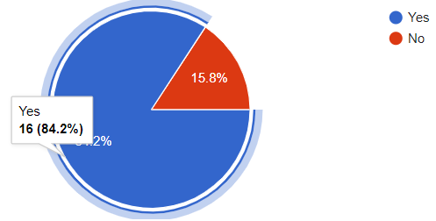

**Analysis:**

1. As per the Table No.2 respondents were asked that are they the part of top outlet program of different companies?
2. Where 84.2% outlets are the part of top outlet program of other companies than that of ITC & 15.8% are not the part of top outlet program of other companies.

**Interpretation:**

* From above Pie Chart researcher can interpret that, majority of outlets register under the ITCs top outlet program i.e., Frist Club are also the part of competitors top outlets program which includes ISS, Grocery, Bakery & Chemist.
* Through this researcher can be able to do proper comparative analysis on the basis of competition drive since 84.2% are enrolled in different companies’ top outlet programs.

**Que.3: Are you enrolled in First Club Outlet for ITC?**

**Table No: 3**

|  |  |  |  |
| --- | --- | --- | --- |
| **Sr.no** | **Response** | **No. of Respondents** | **Percentage** |
| 1 | Yes | 17 | 89.5% |
| 2 | No | 2 | 10.5% |

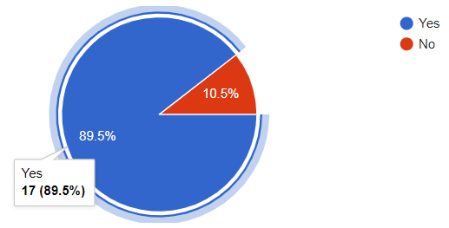

**Analysis:**

1. As per the Table No.3 respondents were asked that were they enrolled in Frist Club outlet for ITC?
2. Where 89.5% of outlets are enrolled to ITCs top outlet program on other hand 10.5% are not enrolled in top outlet program for ITC.

**Interpretation:**

* From above Pie Chart researcher can interpret that, there are some outlets i.e., 10.5% which are untap by ITC for top outlet program but they are enrolled for different companies. However, their sale of ITC is fairly good.

**Que.4: Other than ITC which companies are you enrolled in?**

**Table No: 4**

|  |  |  |  |
| --- | --- | --- | --- |
| **Sr.no** | **Responses** | **No. of Respondents** | **Percentages** |
| 1 | Nestle | 10 | 52.6% |
| 2 | Britannia | 13 | 68.4% |
| 3 | Parle | 00 | 0% |
| 4 | HUL | 10 | 52.6% |
| 5 | None | 04 | 21.1% |

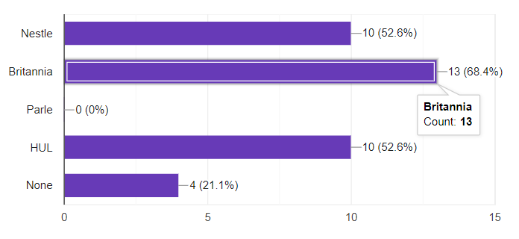

**Analysis:**

1. As per the Table No.4 respondents were asked that were asked other than ITC which companies are they enrolled in?
2. Where most were enrolled to Britannia with 68.4%, then to Nestle & HUL with 52.6% respectively, there are no outlets which are enrolled for Parle i.e., 0%, 21.1% of outlets are not enrolled to any other companies other than ITC.

**Interpretation:**

* From above histogram researcher can interpret that, other than ITC top outlets are also enrolled to Britannia, Nestle & HUL where there are no Pay-outs given by Parle but through the conversation with the top outlet owners researcher came to know Parle provides special scheme to them.
* There are some top outlets which are untapped by competitors where only ITC is providing pay-outs.

**Que.5: How often do you get incentives from companies?**

**Table No: 5**



|  |  |  |  |
| --- | --- | --- | --- |
| **Sr.no** | **Responses** | **No. of Respondents** | **Percentages** |
| 1 | Monthly Basis | 18 | 100% |
| 2 | On completion of target | 07 | 38.9% |
| 3 | Quarterly Basis | 01 | 5.6% |

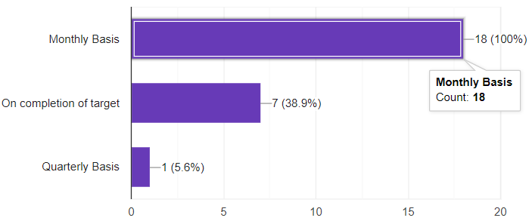

**Analysis:**

1. As per the Table No.5 respondents were asked that how often they get incentives from companies?
2. Where all top outlets get incentives on monthly basis i.e., 100%, also some companies (38.9%) get incentives after completion of target & only 5.6% gets incentives Quarterly basis.

**Interpretation:**

* From above histogram researcher can interpret that, the incentives which are given by the companies are on monthly basis. There are some top outlets whom incentives are given after completion of target & on quarterly basis.

**Que.6: On what basis the pay-outs have been given to you?**

**Table No: 6**

|  |  |  |  |
| --- | --- | --- | --- |
| **Sr.no** | **Responses** | **No. of Respondents** | **Percentage** |
| 1 | End Caps | 10 | 52.6% |
| 2 | Shelves | 4 | 21.1% |
| 3 | Baskets | 3 | 15.8% |
| 4 | Fridge | 2 | 10.5% |

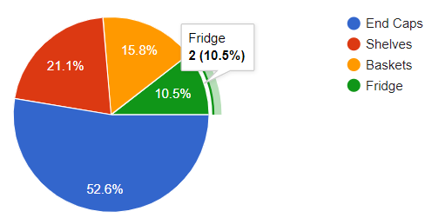

**Analysis:**

1. As per the Table No.6 respondents were asked that, on what basis the pay-outs have been given to them?
2. Where 52.6% of outlets gets playouts on the basis of End caps, 21.1% gets pay-outs on the basis of Shelves, 15.8% on the basis of Baskets & 10.5% on the basis of Fridge.

**Interpretation:**

* From above histogram researcher can interpret that, pay-outs are mostly given on the basis of End caps as ISS stores are meanly involved in top outlet programs of the companies, secondly on the basis of Shelves. Thirdly on the basis of Baskets & lastly on the basis of Fridge. These criteria of pay-out vary on the basis of what type of outlet is it.

**Que.7: In which form will you prefer the pay-outs the most?**

**Table No: 7**

|  |  |  |  |
| --- | --- | --- | --- |
| **Sr.no** | **Responses** | **No. of respondents** | **Percentage** |
| 1 | Bank transfer | 9 | 47.4% |
| 2 | Bill Cutting | 6 | 31.6% |
| 3 | Both | 4 | 21.1% |

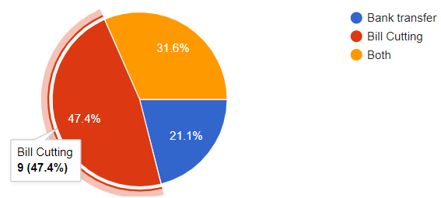

**Analysis:**

1. As per the Table No.7 respondents were asked that, in which form will they prefer the pay-outs the most?
2. Where 47.4% of Top outlets prefers the pay-outs through bill cuttings, 21.1% of them prefers the pay-outs through Bank transfer & 31.6% of them prefer the pay-outs through both Bank Transfer & Bill cutting.

**Interpretation:**

* From above Pie Chart researcher can interpret that, most of the outlets prefer bill cutting as a way of pay outing rather than bank transfer coz., through interview researcher came to know that owners think that through bill cutting they can be aware of pay-outs & which will not be possible through bank transfer as lots of transaction takes place through those accounts.

**Que.8: What does companies offers you with their product?**

**Table No: 8**

|  |  |  |  |
| --- | --- | --- | --- |
| **Sr.no** | **Responses** | **No. of Respondent** | **Percentage** |
| 1 | Baskets | 16 | 88.9% |
| 2 | Hangers | 14 | 77.8% |
| 3 | Racks | 12 | 66.7% |
| 4 | Fridge | 9 | 50% |

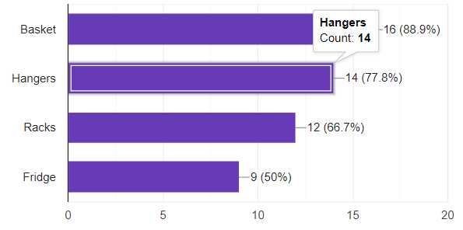

**Analysis:**

1. As per the Table No.8 respondents were asked that, what does companies offer them with their products?
2. Where 88.9% of outlets are offered basket with product, secondly with 77.8% hangers are offered, thirdly with 66.7% racks are offered & lastly with 50% fridge are offered.

**Interpretation:**

* From above histogram researcher can interpret that, racks are offered by many companies to the top outlets to showcase their products more efficiently, Baskets are meanly given to keep the products like noodles packs for visibility, Hangers are provided for laddies of confectioneries & Fridges are given for preservation of company’s products like juices, Chocolates Bars etc.

**Que.9: How targets are communicated to you by the companies?**

**Table No: 9**

|  |  |  |  |
| --- | --- | --- | --- |
| **Sr.no** | **Responses** | **No. of Respondents** | **Percentage** |
| 1 | By In Voice | 2 | 10.5% |
| 2 | By Mobile App | 9 | 47.4% |
| 3 | By SMS | 7 | 36.8% |
| 4 | By WhatsApp | 1 | 5.3% |

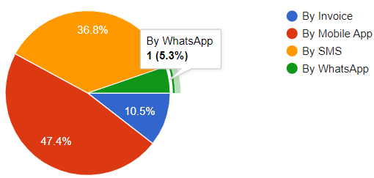

**Analysis:**

1. As per the Table No.9 respondents were asked that, how targets are communicated to them by companies?
2. Where 47.4% of top outlets are communicated about their target with the help of Mobile Apps, 36.8% of them are communicated their target with the help of SMS, 10.5% of them with the help of Invoice & 5.3% of the with the help of WhatsApp.

**Interpretation:**

* From above histogram researcher can interpret that, since companies have their own Mobile Apps they are communicating the targets with the help of it , also with the help of SMS the targets are been communicated to top outlets. Invoice is outdated way of communicating targets still it’s being use in some of the outlets. WhatsApp is rarely use of communication of targets.

**Que.10: How much target is given by companies on monthly basis to you?**

**Table No: 10**

|  |  |  |  |
| --- | --- | --- | --- |
| **Sr.no** | **Responses** | **No. of Respondents** | **Percentage** |
| 1 | <10000 | 5 | 26.3% |
| 2 | 10000 to 50000 | 3 | 15.8% |
| 3 | 50000 to 100000 | 4 | 21.21% |
| 4 | 100000 to 150000 | 2 | 10.5% |
| 5 | 150000 to 200000 | 4 | 21.1% |
| 6 | 200000 to 250000 | 1 | 5.3% |
| 7 | >250000 | 0 | 0% |

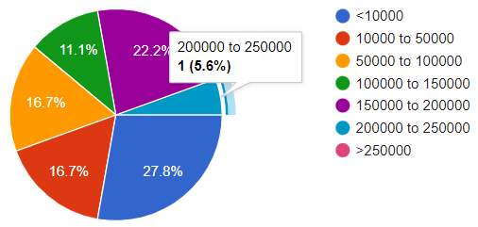

**Analysis:**

1. As per the Table No.10 respondents were asked that, how much target is given by companies to them?
2. Where 21.1% of top outlet owners said that companies are giving them target between 50000 to 100000, 26.3% of them said that companies are giving target less than 10000, 15.8% of them said that companies are giving target between 10000 to 50000, 21.1% of them said that companies are giving target between 50000 to 100000 & 150000 to 200000 respectively 10.5% of them said that companies are giving target between 100000 to 150000 & 1% of them said that companies are giving target between 200000 to 250000.

**Interpretation:**

* From above Pie Chart researcher can interpret that, the targets given by the companies which are less than 10000 to the outlets are mainly retail stores of grocery, bakery & Chemist. While the targets which are more than 100000 are ISS stores whose sales are more. Through the conversation most of these bigger targets > 200000 are given by HUL.

**Que.11:** **Is any special scheme/ pay-outs given by companies to you?**

**Table No: 11**

|  |  |  |  |
| --- | --- | --- | --- |
| **Sr.no** | **Responses** | **No. of Respondents** | **Percentage** |
| 1 | Yes | 13 | 68.4% |
| 2 | No | 6 | 31.6% |

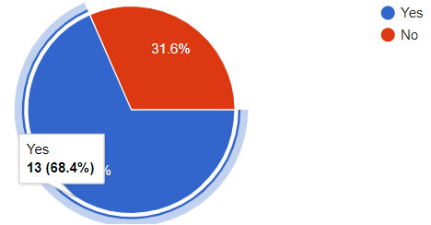

**Analysis:**

1. As per the Table No.11 respondents were asked that, is any special schemes/ pay-outs given by the companies to them?
2. Where 68.4% of the top outlets said Yes on the other hand 31.6% of the top outlets said No.

**Interpretation:**

* From above Pie Chart & through interview with owners’ researcher can interpret that, the top outlets who are getting special schemes are given by Parle, as they do not give any pay-outs to these outlets, they provide special scheme to these outlets.

**Que.12:** **If “Yes” how will you rate them?**

**Table No: 12**

|  |  |  |  |
| --- | --- | --- | --- |
| **Sr.no** | **Responses** | **Rating Scale (pt)** | **Respondents** |
| 1 | Pay-outs/schemes | 5 | 5 |
|  |  | 4 | 7 |
|  |  | 3 | 1 |
|  |  | 2 | 0 |
|  |  | 1 | 0 |
| 2 | Display: | 5 | 0 |
|  |  | 4 | 5 |
|  |  | 3 | 7 |
|  |  | 2 | 1 |
|  |  | 1 | 0 |

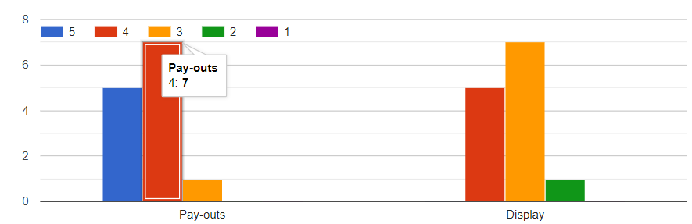

**Analysis:**

1. As per the Table No.12 respondents were asked that, if they are getting special scheme from any company then how they will rate it on the basis of Pay-outs & Display?
2. Where for Pay-outs: 5 outlets rated 5 points, 6 outlets rated 4 points & 1outlet rated 3 points.
3. For Display: 0 outlet rated 5 points, 5 outlets rated 4 points, 6 outlets rated 3 points & 1 outlets rated 2 points.

**Interpretation:**

* From above histogram researcher can interpret that, Pay-outs are rated higher than that of Display. Where for Pay-outs majority of outlets have rated between 4-5 points,on other hand for Display majority of outlets have rated 3 points. Thus, Parle have given Pay-outs/Scheme effectively but haven’t focused on Display

**Que.13: Rate ITCs schemes based on following parameters:**

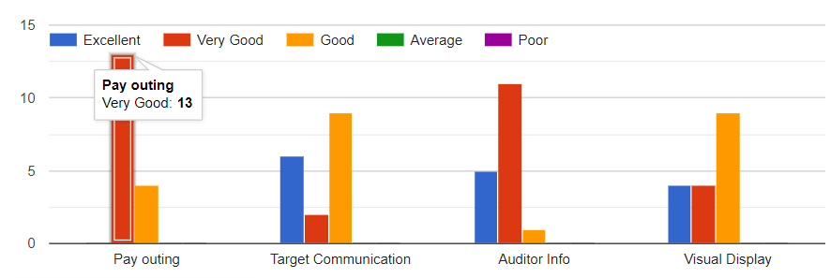**Table No: 13**

|  |  |  |  |
| --- | --- | --- | --- |
| **Sr.no** | **Responses** | **Rating Scale(pt)** | **No. of Respondents** |
| 1 | Pay outing: | Poor | 0 |
|  |  | Average | 0 |
|  |  | Good | 2 |
|  |  | Very Good | 15 |
|  |  | Excellent | 0 |
| 2 | Target Communication: | Poor | 0 |
|  |  | Average | 0 |
|  |  | Good | 5 |
|  |  | Very Good | 3 |
|  |  | Excellent | 9 |
| 3 | Auditor Info: | Poor | 0 |
|  |  | Average | 0 |
|  |  | Good | 1 |
|  |  | Very Good | 11 |
|  |  | Excellent | 5 |
| 4 | Visual Display: | Poor | 0 |
|  |  | Average | 0 |
|  |  | Good | 6 |
|  |  | Very Good | 4 |
|  |  | Excellent | 7 |

**Analysis:**

1. As per the Table No.13 respondents were asked that, how will they rate ITCs schemes on the basis of Pay-outs, Target Communication, Auditor Info & Visual Display.
2. For **Pay-outs:** 13 outlets Rated Very Good & 4 rated Good, for **Target Communication:** 6 outlets rated excellent, 2 outlets rated Very good & 9 outlets rated good, For **Auditor Info:** 5 outlets rated excellent, 11 outlets rated very good & 1 outlets rated good, For **Visual Display:** 4 outlets rated Excellent, 4 outlets rated very good & 9 outlets rated good.

**Interpretation:**

* From above histogram researcher can interpret that, outlets are satisfied with pay outing the most secondly with auditor info then Target Communication & lastly visual display

**CHAPTER:10**

**COMPARATIVE ANALYSIS OUTCOMES**

During this research project researcher have compared top outlets for comparative analysis

**Top outlets are divided in three different categories they are as follow:**

1. ISS (Independent Self Services)
2. Grocery
3. Bakery
4. Chemist

Main intention behind doing the comparative analysis is to know which types of top outlets are given more priority by different companies than other.

**Following is the outcome on the basis of comparison between 4 different categories of top outlets:**

1. Compared to all the 4 categories ISS stores are most in numbers in top outlet program for ITC on the other hand there are very few Grocery, Bakery & Chemist involved.
2. Even though Britannia has maximum number of same enrolments which ITC has for top outlets program but they didn’t have focused on chemist & Bakeries at all like ITC did.
3. The owners of top outlets meanly of groceries & bakeries are not known to their targets just because the outdate source of target communication is meanly adopted by ITC i.e., SMS. While other companies like HUL, nestle are communicating through Invoice or company applications.
4. Visual displays are manly given to the top outlets which are in the categories of ISS and not for the retailers with traditional outlet. Therefore, companies should focus on implementing visual displays in outlets like grocery, bakeries.
5. Britannia is not targeting outlets which are country side or are based on village level while ITC is able to provide pay-outs to these traditional retailers
6. Baskets are been given to maximum outlets who are enrolled to top outlet program of ITC and even other brands but they should be provided to these traditional retailers like grocery, bakeries & not for ISS stores coz., these baskets will be more use-full to these traditional retailers then that of ISS stores.
7. Since ISS gives most of the sales to the companies therefore targets given to them are higher than that of traditional outlets like grocery & Bakeries
8. Most of the ISS outlets prefers the pay-outs through bill cutting but if we look at the grocery stores retailers prefers pay-outs online bank transfer or even bill cutting. The ISS owners say is pay-outs are given though online bank transfer they don’t get aware about that as several transactions takes place through those particular accounts on daily basis.

**CHAPTER:11**

**FINDINGS, CONCLUSION & SUGGESTION OF THE STUDY:**

1. **FINDINGS:**

* *During research, researcher observed the following findings:*

1. Other than ITC almost 85% of top outlets are enrolled for different companies’ top outlet program.
2. Almost 78.94% top outlets are enrolled to ITCs top outlet programs & remaining which are not enrolled are enrolled different companies’ top outlet program.
3. Top outlets are enrolled to companies like Britannia, Nestle & HUL but interestingly none is enrolled to Top outlet program of Parle since Parle don’t have its program but provides special schemes to these outlets.
4. 100% of top outlets gets the incentives monthly basis where some of them rarely gets after completion of target & quarterly basis.
5. Almost 53% of top outlets gets the pay-outs for companies on End Caps which is maximum since most of the outlets are ISS stores in top outlet programs.
6. 47% of top outlet owners prefers the pay-outs through bill cuttings according to them pay-outs are easily noticeable.
7. Maximum companies have offered these outlets Baskets with 89% of them aggreging on it.
8. Almost 47% of companies are communicating the target to these outlets with the help of Mobile App & 37% through SMS
9. 21.1% of the top outlets are given target between 50000 to 100000 & 150000 to 200000 respectively.
10. Almost 68% of the top outlets get special schemes from company meanly Parle. Where parle provides good schemes/pay-outs but haven’t focus on display.
11. Top outlets were told to rated ITC on the basis of Pay-outing, target communication, auditor info & visual display. Maximum outlets voted more for pay-outing, secondly for auditor info, thirdly for target communication & lastly visual display.
12. **CONCLUSION:**
13. Through the project repost researcher came to know that display advertising is carried on in these top outlets in the form of hoardings, Stickers & indirectly through product offerings.
14. Through this project report researcher came to know what competition is driven by different companies in top outlets in Shrirampur region. Thus, through research, researcher came to know that for making product sale companies tried to provide monthly incentives, pay-outs, product offerings, special schemes etc.
15. Company like Parle which does not provide any sort of pay-outing to top outlets like other companies such as ITC, Britannia, Nestle & HUL do. But they provide some special schemes to these top outlets so that they can earn good margin & company can able to increase sale.
16. Companies do provide product offerings like Hangers, Baskets, Racks, Fridge etc to these top outlet stores as a compliment on their performance. Which also motivates these outlets to perform their best for achieving the targets.
17. On analysing top outlets perception towards ITCs schemes provided to them on the basis of Pay-outing, target communication, Auditor Info & Visual Display. Top outlets rated pay-outing the most Auditor info is secondly rated then target communication & visual display.

1. **SUGGESTIONS:**
2. Target communication is where ITC should look to improve except ISS outlets, most outlets like grocery & bakery are unaware of what are the targets given to them.
3. Visual display is playing vital role in advertisement or marketing of product thus increment in visual display in top outlets can improve sales.
4. Through interviewing the owners of top outlets researcher came to know that they are preferring bill cutting more than that of bank transfer for pay-outing coz., according to them it helps to be aware bout pay-out as its available on bill itself.

**\*\*\*\*\*\***

**CHAPTER:11**

**BIBLOGRAPHY:**

**Company Profile:** <https://www.itcportal.com/about-itc/profile/index.aspx>

**Industry Profile:** <https://www.ibef.org/industry/f>

**Organisational Structure:** <https://www.itcportal.com/about-itc/leadership/index.aspx>

**CHAPTER: 12**

**ANNEXURE:**

1. **Name of the outlet:**

________________

1. **Contact No:**

________________

1. **Email ID:**

________________

1. **What is the type of outlet?**
2. ISS
3. Bakery
4. Grocery
5. Chemist
6. **Are you a part of top outlet program for different companies?**
7. Yes
8. No
9. **Are you enrolled in Frist Club outlet for ITC?**
10. Yes
11. No
12. **Other then ITC which companies are you enrolled in?**
13. Nestle
14. Britannia
15. Parle
16. HUL
17. None
18. **How often do you get incentives from companies?**
19. Monthly
20. On completion of target
21. Quarterly basis
22. **On what basis the pay-outs have been given to you?**
23. End Caps
24. Shelves
25. Baskets
26. Fridge
27. **In which form you will prefer the pay-outs the most?**
28. Bill cutting
29. Bank transfer
30. Both
31. **What does companies offer you with their product?**
32. Basket
33. Hangers
34. Racks
35. Fridge
36. **How targets are communicated to you by companies?**
37. By Invoice
38. By mobile app
39. By SMS
40. By WhatsApp
41. **How much target is given by companies on monthly basis to you**?
42. <10000
43. 10000 to 50000
44. 50000 to 100000
45. 100000 to 150000
46. 150000 to 200000
47. 200000 to 250000
48. >250000
49. **Are any special scheme/pay-outs plans given by companies to you?**
50. Yes
51. No
52. **If “YES”, how will you rate them:**
53. Pay-outs: 5 4 3 2 1
54. Display: 5 4 3 2 1
55. **Rate ITCs schemes based on following parameters:**

Excellent Very Good Good Average Poor

1. Pay-outing:
2. Target communication:
3. Auditor info:
4. Visual display:
5. **Any Suggestions:**

_____________________

*****